Problem No : 2302056_07

Problem Name : Write a C program to display following variables.  
a+ c, x + c,dx + x, ((int) dx) + ax, a + x, s + b, ax + b, s + c, ax + c, ax + ux

Input :

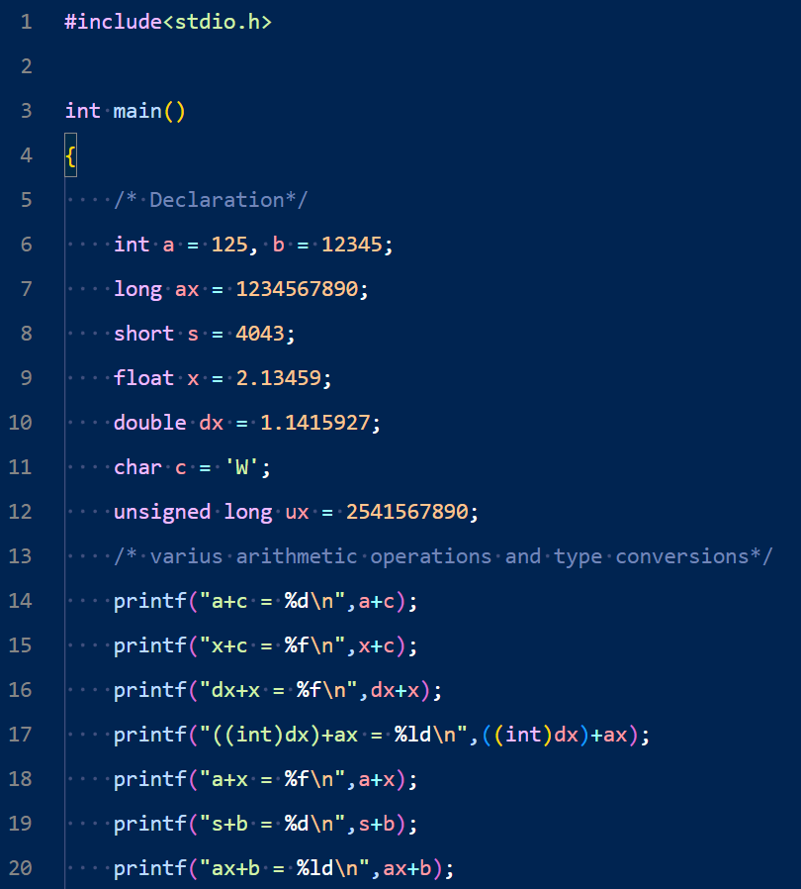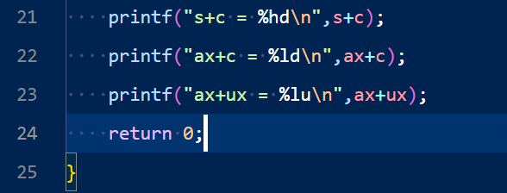

Output :

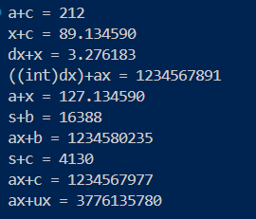

Problem No : 2302056_08

Problem Name : Write a C program to convert specified days into years, weeks and days.

Input :

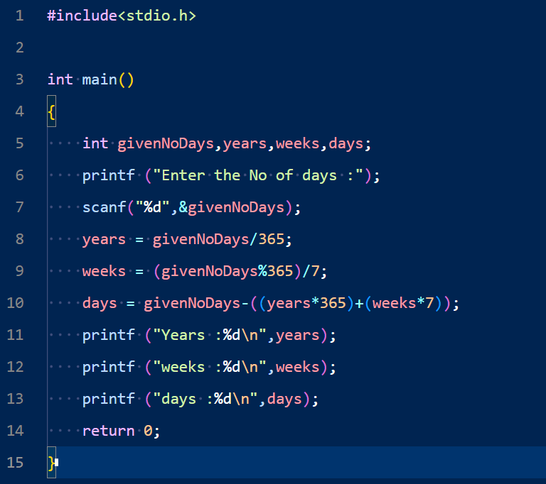

Output :

Problem No : 2302056_09

Problem Name : Write a C program that accepts two integers from the user and calculates the sum of the two integers.

Input :

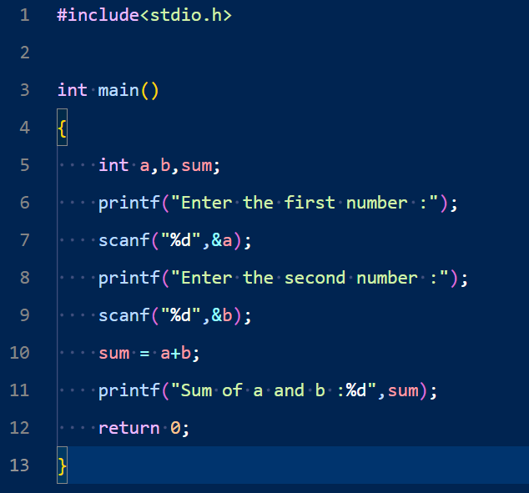

Output :

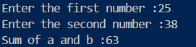

Problem No : 2302056_10

Problem Name : Write a C program that accepts two integers from the user and calculates the product of the two integers.

Input :

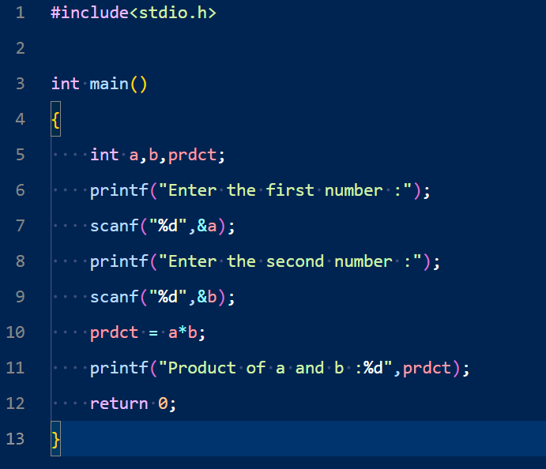

Output :

Problem No : 2302056_11

Problem Name : Write a C program that accepts two item's weight and number of purchases (floating point values) and calculates their average value.

Input :

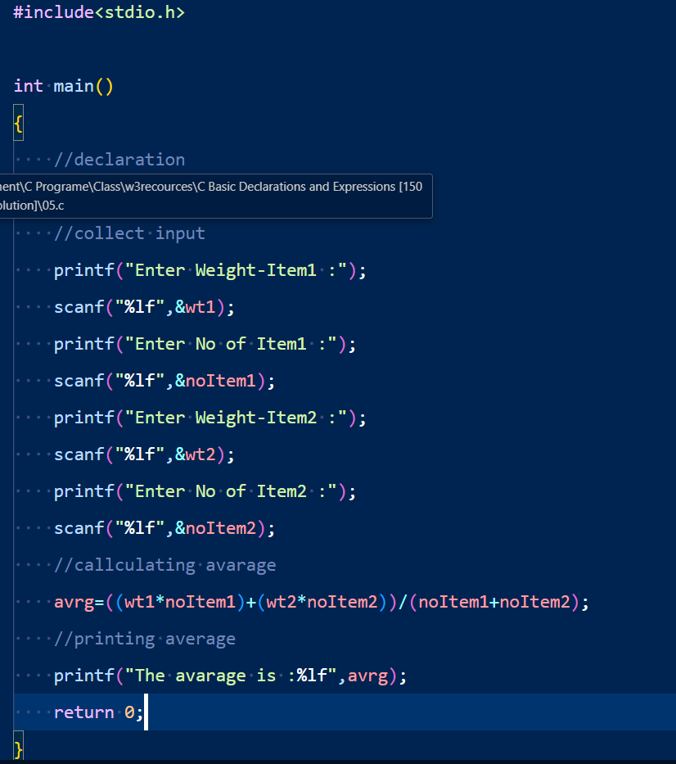

Output :

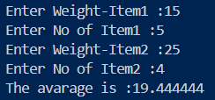

Problem No : 2302056_12

Problem Name : Write a C program that accepts an employee's ID, total worked hours in a month and the amount he received per hour. Print the ID and salary (with two decimal places) of the employee for a particular month.

Input :

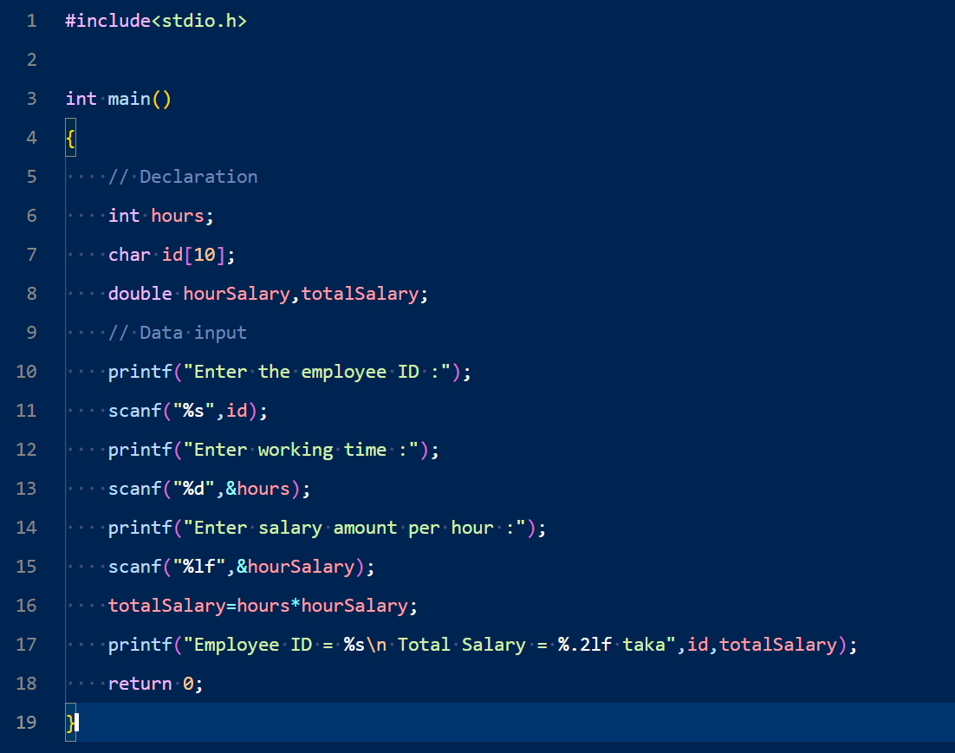

Output :

Problem No :2302056_13

Problem Name : Write a C program that accepts three integers and finds the maximum of three.

Input :

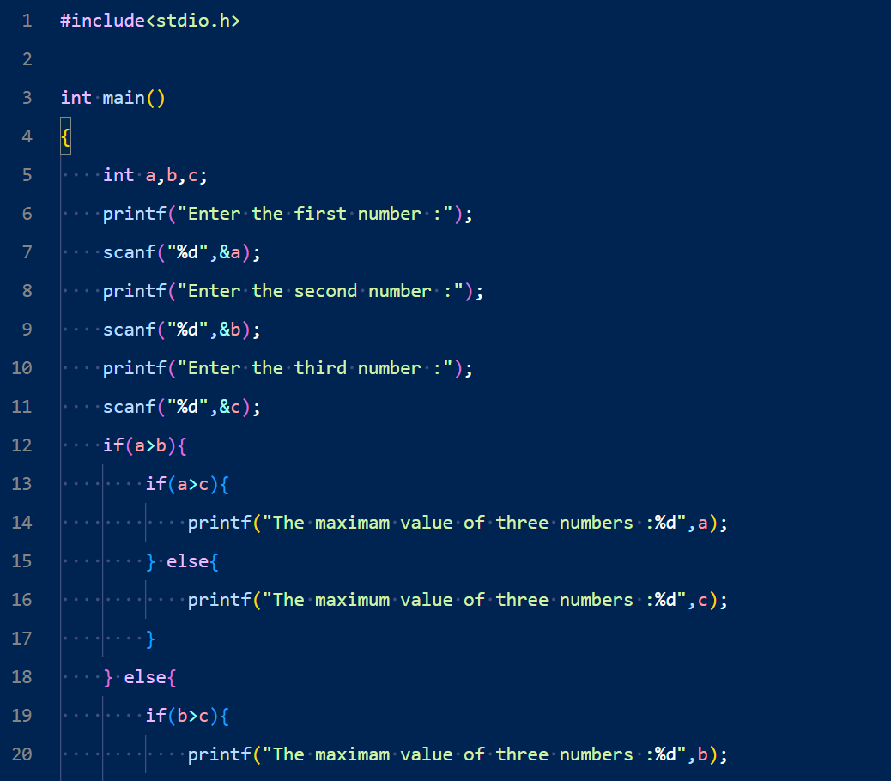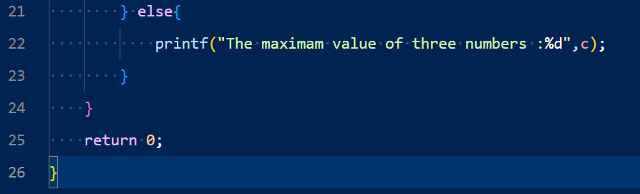

Output :

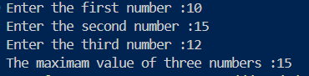

Problem No :2302056_14

Problem Name : Write a C program to calculate a bike’s average consumption from the given total distance (integer value) travelled (in km) and spent fuel (in litters, float number – 2 decimal points).

Input : 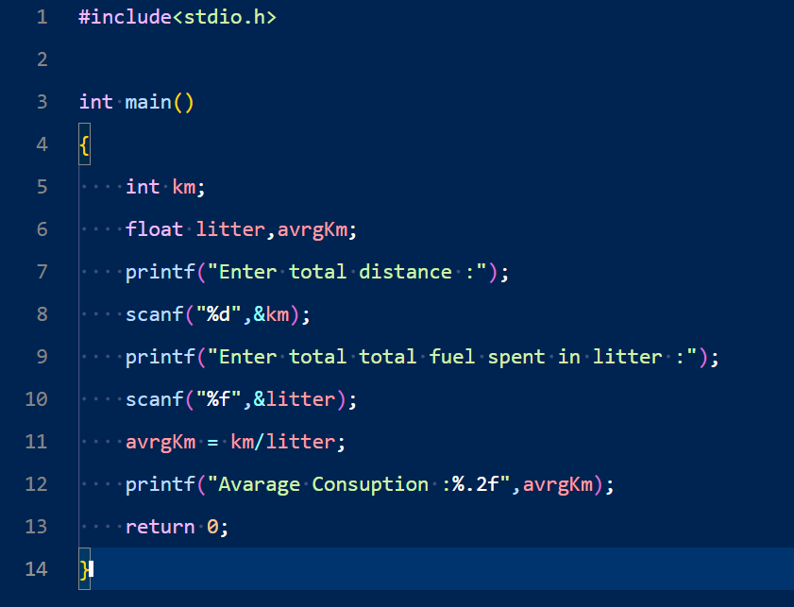

Output :

Problem No : 2302056_15

Problem Name : Write a C program to calculate the distance between two points.

Input :

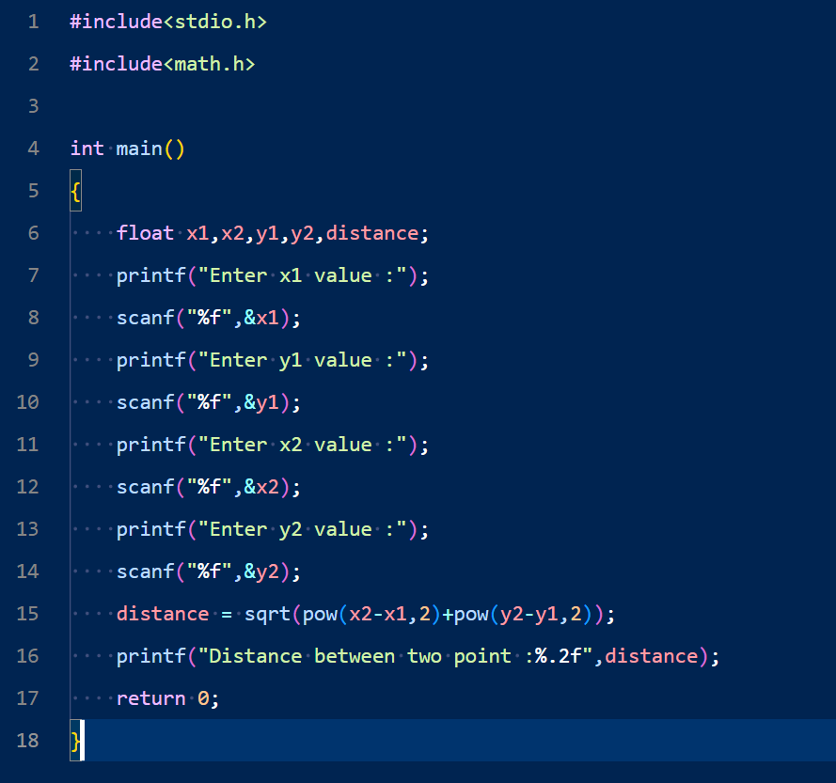

Output :

Problem No : 2302056_16

Problem Name : Write a C program to read an amount (integer value) and break the amount into the smallest possible number of bank notes.

Input :

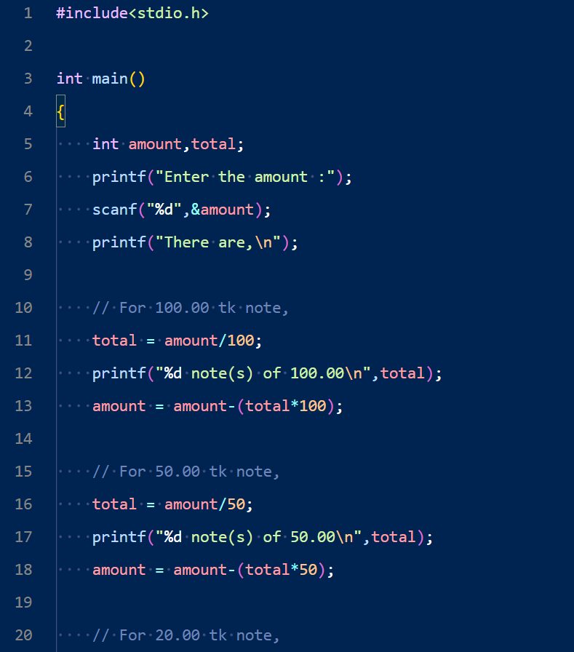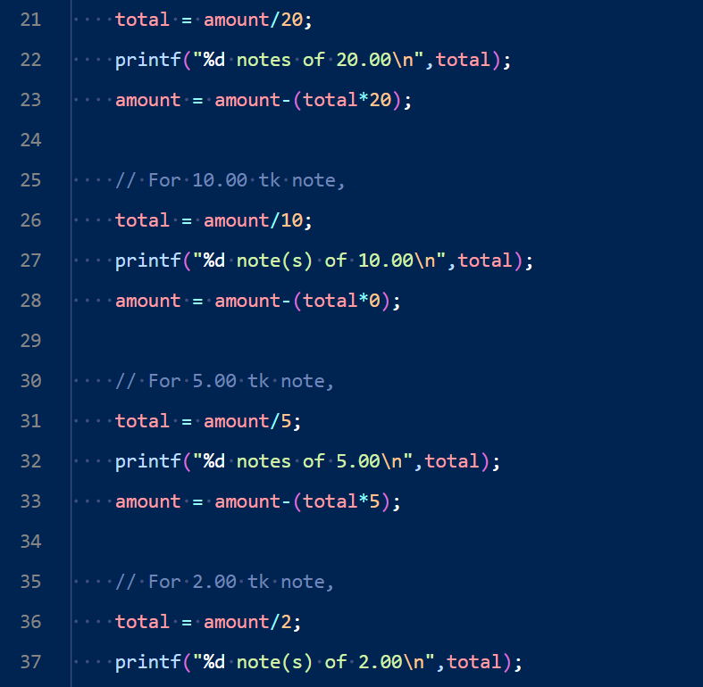

Output :

Problem No : 2302056_17

Problem Name : Write a C program to convert a given integer (in seconds) to hours, minutes and seconds.

Input :

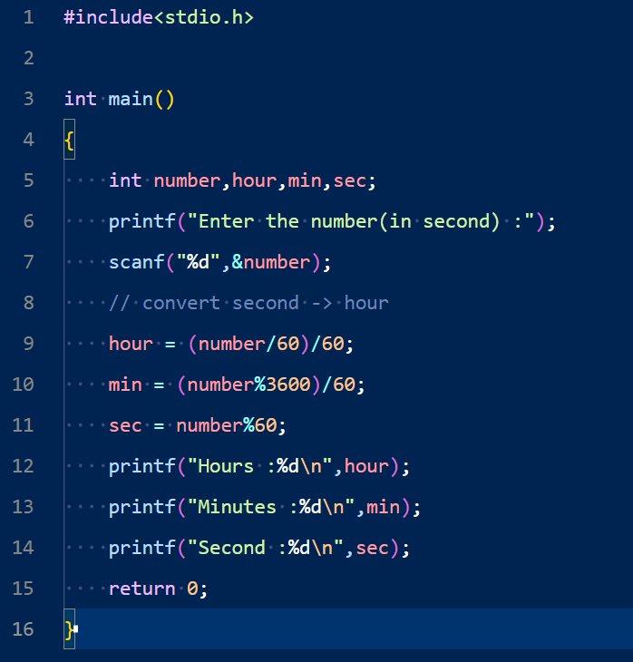

Output :

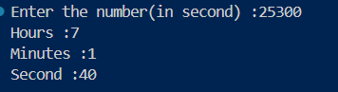

Problem No : 2302056_18

Problem Name : Write a C program to convert a given integer (in days) to years, months and days, assuming that all months have 30 days and all years have 365 days.

Input :

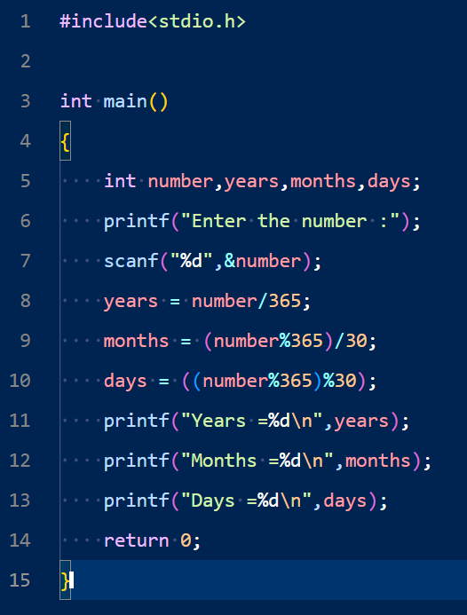

Output :

Problem No : 2302056_19

Problem Name : Write a C program that accepts 4 integers p, q, r, s from the user where q, r and s are positive and p is even. If q is greater than r and s is greater than p and if the sum of r and s is greater than the sum of p and q print "Correct values", otherwise print "Wrong values".

Input :

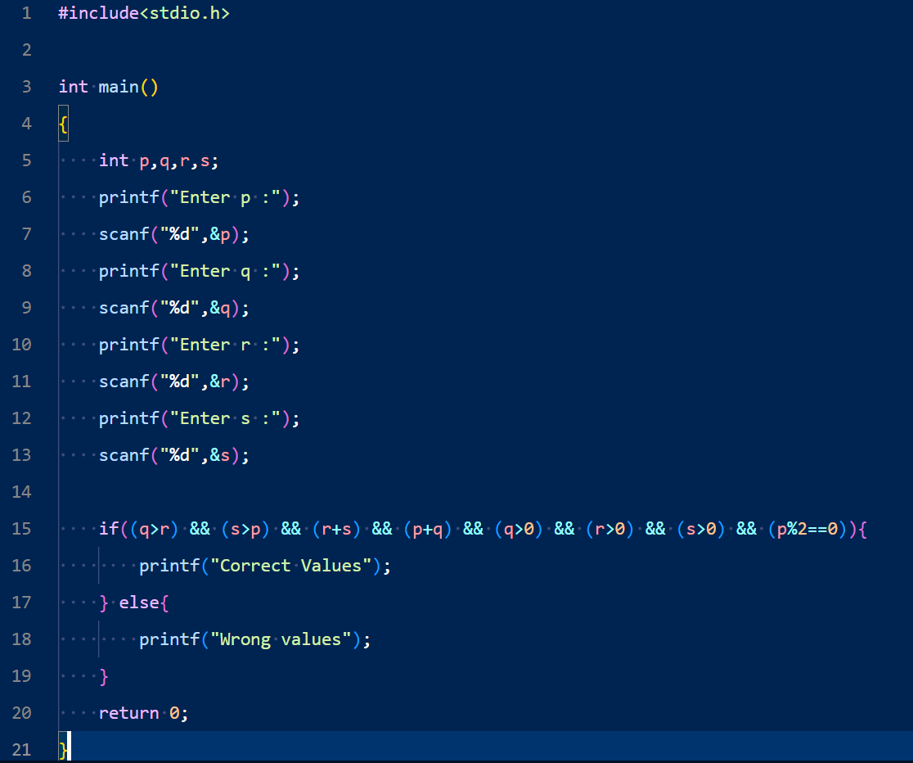Output :

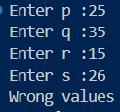

Problem No :2302056_20

Problem Name : Write a C program to print the roots of Bhaskara’s formula from the given three floating numbers. Display a message if it is not possible to find the roots.

Input :

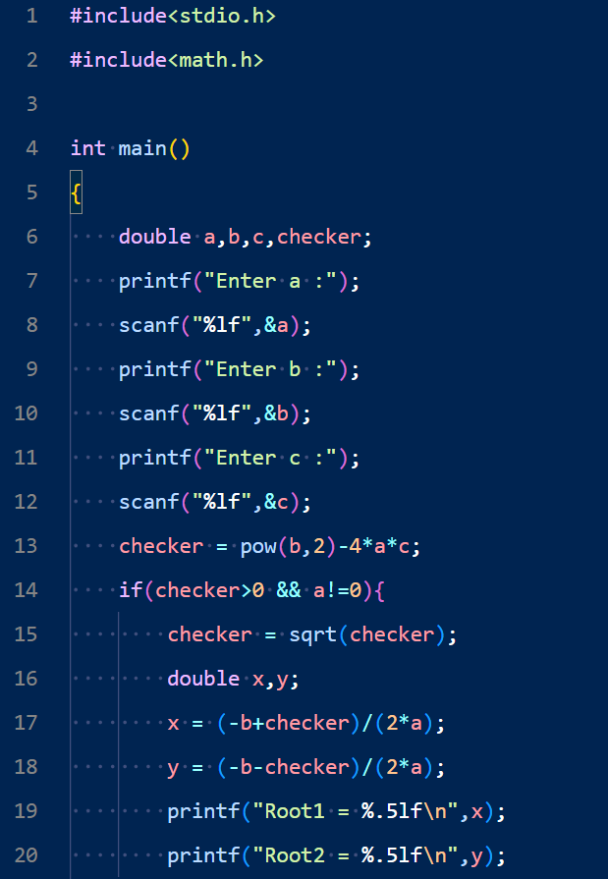

Output :

Problem No : 2302056_21

Problem Name : Write a C program that reads an integer and checks the specified range to which it belongs. Print an error message if the number is negative and greater than 80. Specified Range: [0, 20], [21, 40], [41, 60], [61, 80] .

Input :

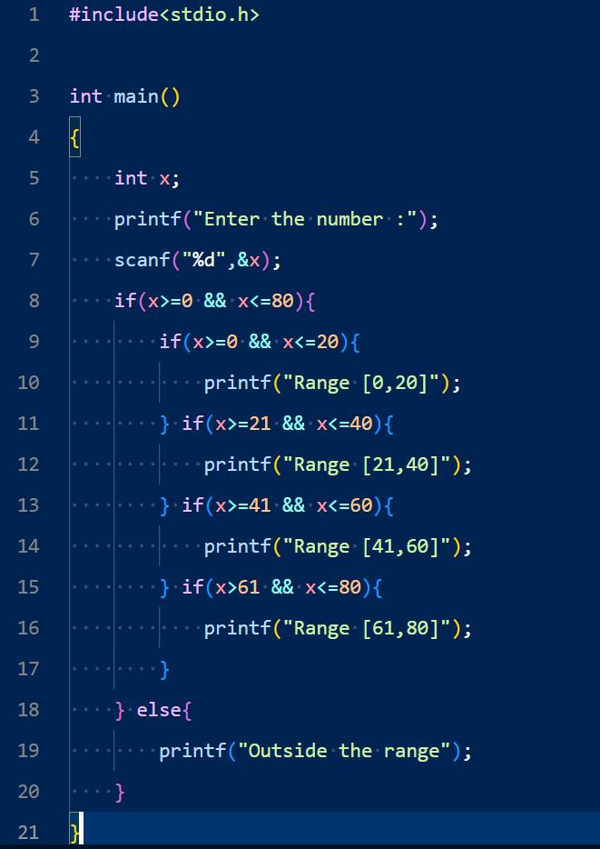Output :

Problem No : 2302056_22

Problem Name : Write a C program that reads 5 numbers and sums all odd values between them.

Input :

Output :

Problem No :2302056_23

Problem Name : Write a C program that reads three floating-point values and checks if it is possible to make a triangle with them. Determine the perimeter of the triangle if the given values are valid.

Input :

Output :

Problem No : 2302056_24

Problem Name : Write a C program that reads two integers and checks whether they are multiplied or not.

Input :

Output :

Problem No : 2302056_25

Problem Name : Write a C program that reads an integer between 1 and 12 and prints the month of the year in English.

Input :

Output :



Problem No : 2302056_26

Problem Name : Write a C program that prints all even numbers between 1 and 50 (inclusive).

Input :

Output :

Problem No : 2302056_27

Problem Name : Write a C program that reads 5 numbers and counts the number of positive numbers and negative numbers.

Input :

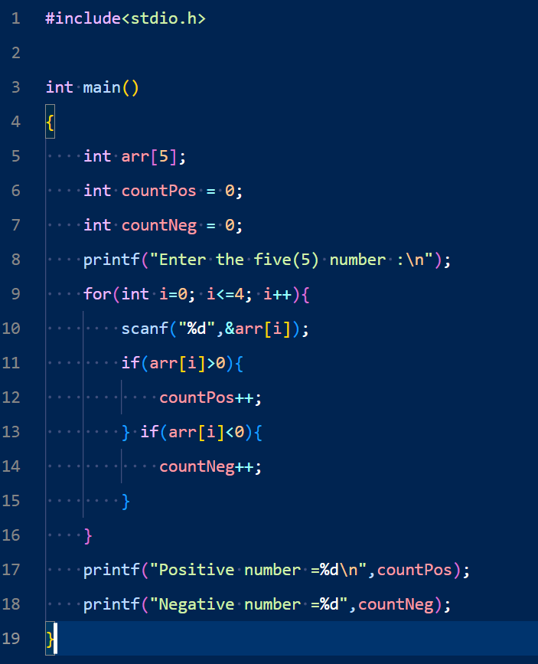Output :

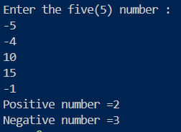

Problem No : 2302056_28

Problem Name : Write a C program that reads 5 numbers, counts the number of positive numbers, and prints out the average of all positive values.

Input :

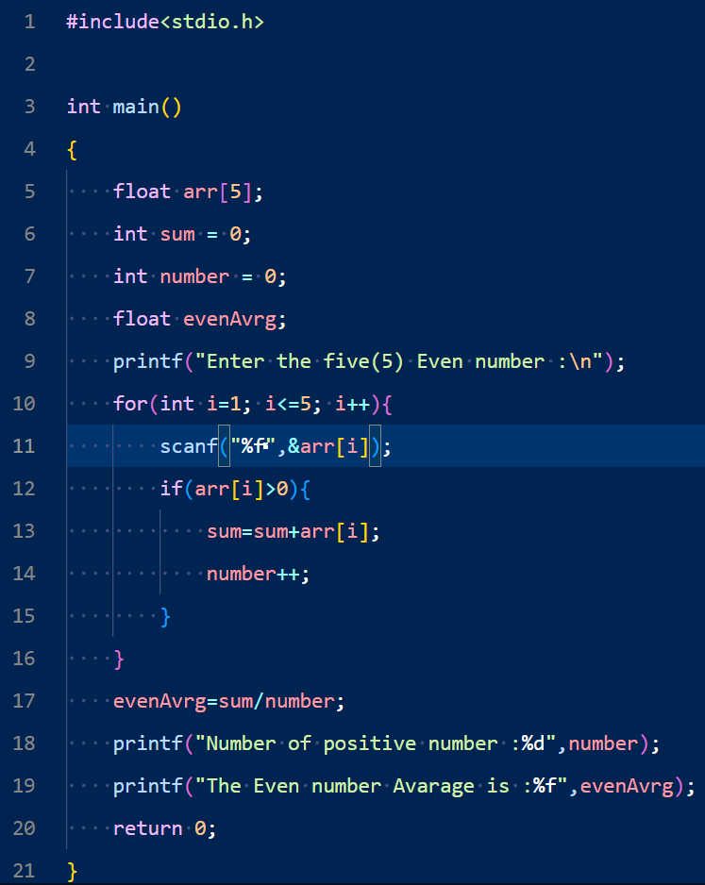Output:

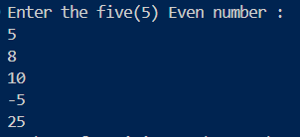

Problem No:2302056_29

Problem Name: Write a C program that read 5 numbers and sum of all odd values between them.

Input:

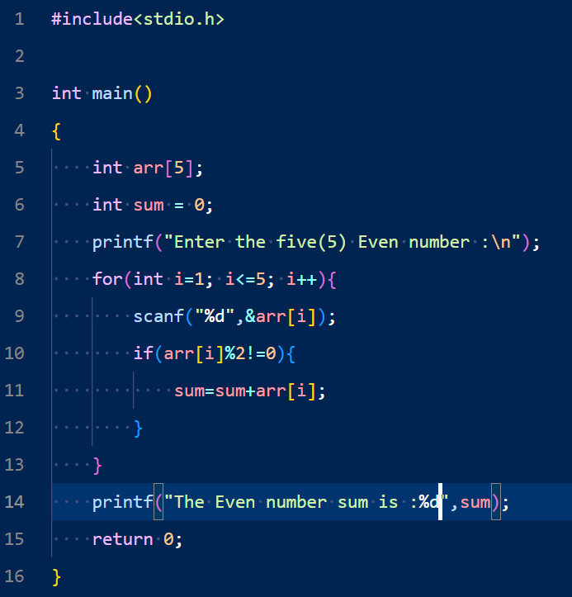Output:

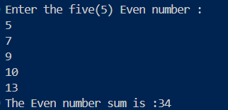

Problem No: 2302056_30

Problem Name: Write a C program to find and print the square of all the even values from 1 to a specified value.

Input:

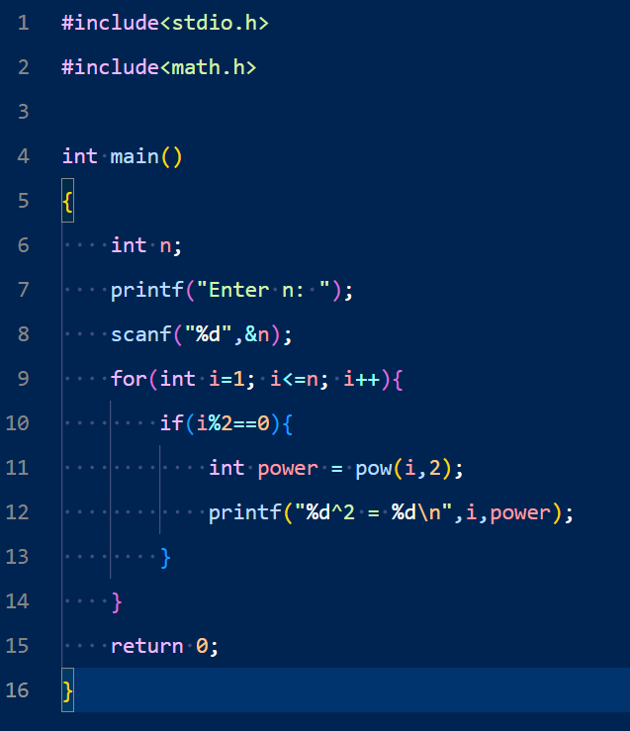Output:

Problem No: 2302056_31

Problem Name: Write a C program to check whether a given integer is positive even, negative even, positive odd or negative odd. Print even if the number is 0.

Input:

Output:

Problem No: 2302056_32

Problem Name: Write a C program to print all numbers between 1 and 100 which are divided by a specified number and the remainder will be 3.

Input:

Output:

Problem No: 2302056_33

Problem Name: Write a C program that accepts some integers from the user and finds the highest value and the input position.

Input:

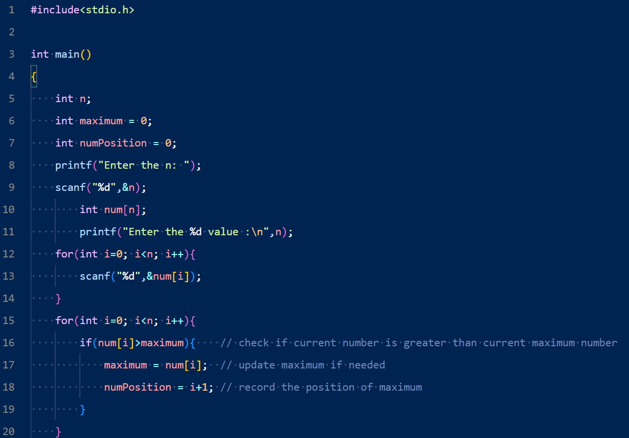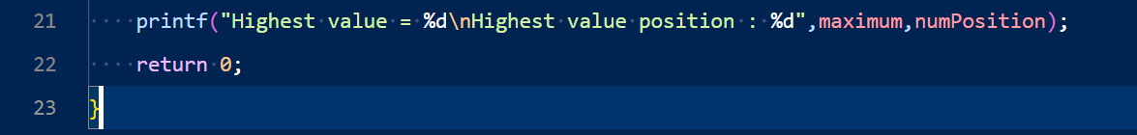

Output:

Problem No:2302056_34

Problem Name: Write a C program to compute the sum of consecutive odd numbers from a given pair of integers.

Input:

Output:

Problem No:2302056_35

Problem Name: Write a C program to check if two numbers in a pair are in ascending order or descending order.

Input:

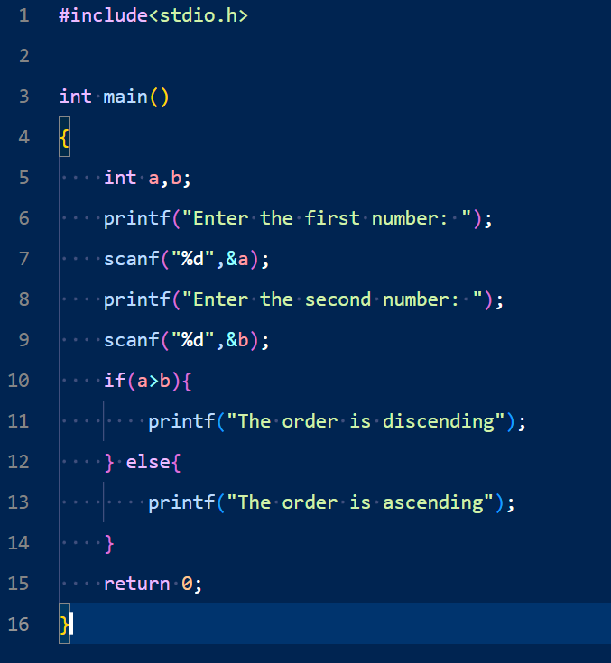

Output:

Problem No: 2302056_36

Problem Name: Write a C program to read a password until it is valid. For wrong password print "Incorrect password" and for correct password print, "Correct password" and quit the program. The correct password is 1234.

Input:

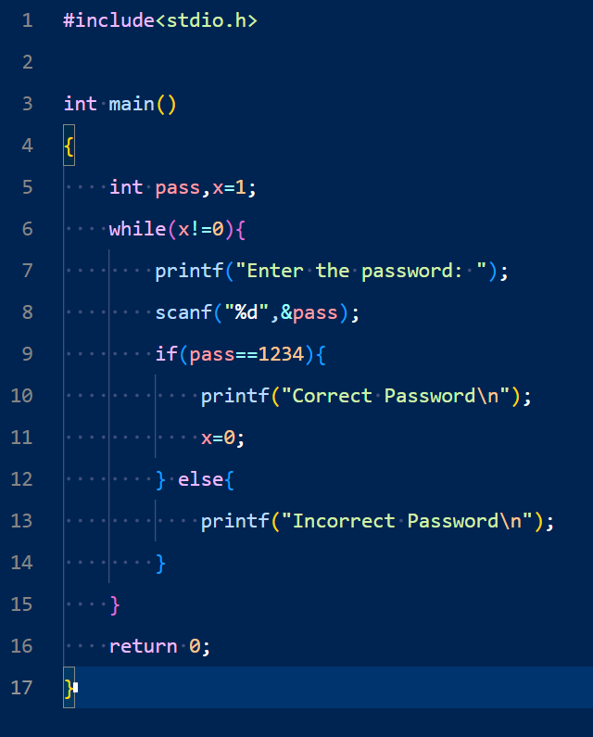Output:

Problem No: 2302056_37

Problem Name: Write a C program to read the coordinates (x, y) (in the Cartesian system) and find the quadrant to which it belongs (Quadrant -I, Quadrant -II, Quadrant -III, Quadrant -IV).

Note: A Cartesian coordinate system is a coordinate system that specifies each point uniquely in a plane by a pair of numerical coordinates.

These are often numbered from 1st to 4th and denoted by Roman numerals: I (where the signs of the (x,y) coordinates are I(+,+), II (−,+), III (−,−), and IV (+,−).

Input:

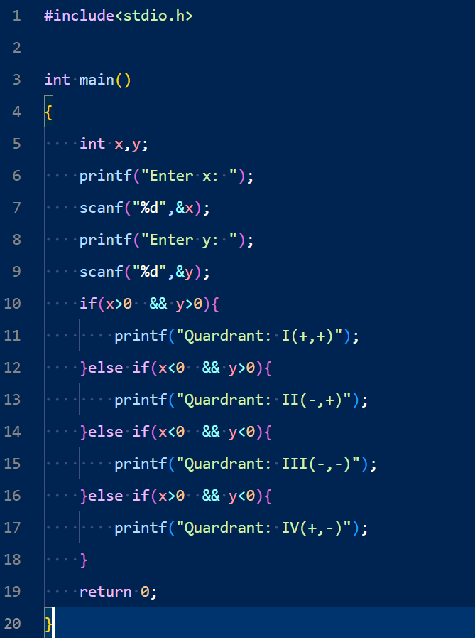Output:

Problem No: 2302056_38

Problem name: Write a program that reads two numbers and divides the first number by the second number. If division is not possible print "Division is not possible".

Input:

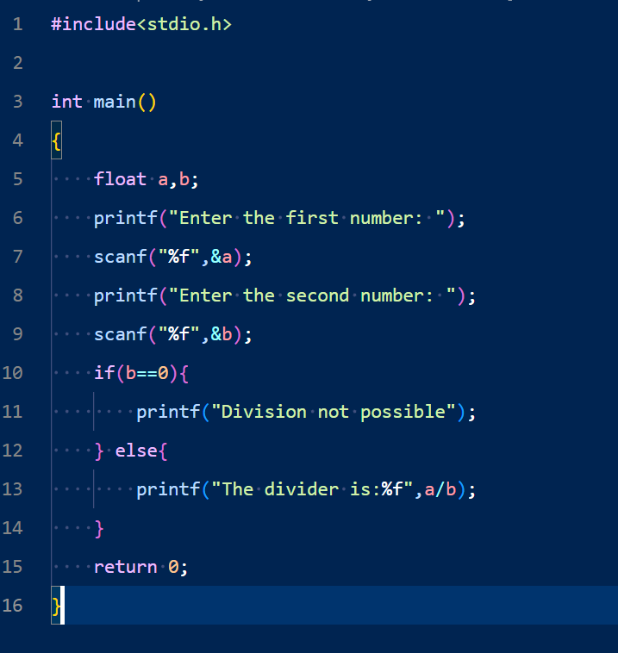Output:

Problem No: 2302056_39

Problem Name: Write a C program to calculate the sum of all numbers not divisible by 17 between two given integer numbers.

Input:

Output:

Problem No: 2302056_40

Problem Name: Write a C program that finds all integer numbers that divide by 7 and have a remainder of 2 or 3 between two given integers.

Input:

Output:

Problem No: 2302056_41

Problem Name: Write a C program to print 3 numbers on a line, starting with 1 and printing n lines. Accept the number of lines (n, integer) from the user.

Input:

Output:

Problem No: 2302056_42

Problem Name: Write a C program to print a number, its square and cube, starting with 1 and printing n lines. Accept the number of lines (n, integer) from the user.

Input:

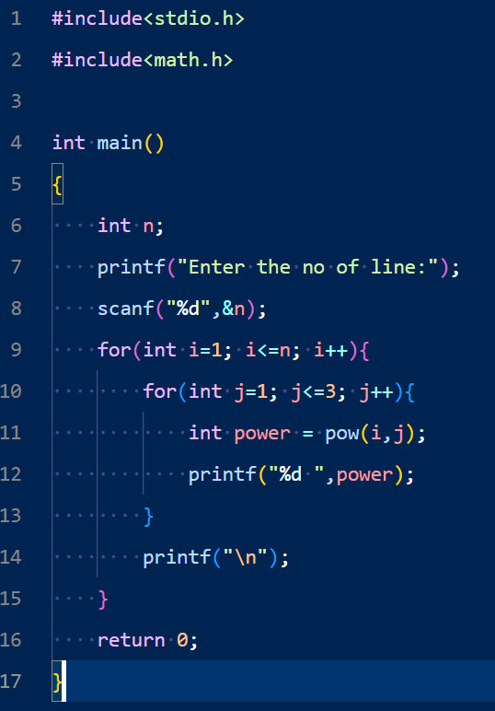

Output:

Problem No: 2302056_43

Problem Name: Write a C program that reads two integers p and q, prints p number of lines in a sequence of 1 to b in a line.

Input:

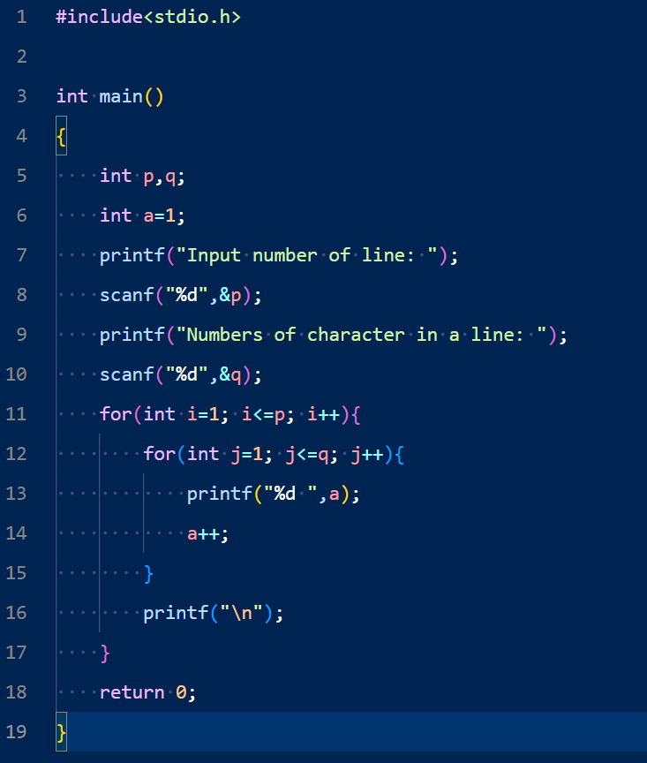Output:

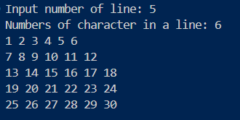

Problem No: 2302056_44

Problem Name: Write a C program to calculate the average mathematics marks of some students. Input 0 (excluding to calculate the average) or a negative value to terminate the input process.

Input:

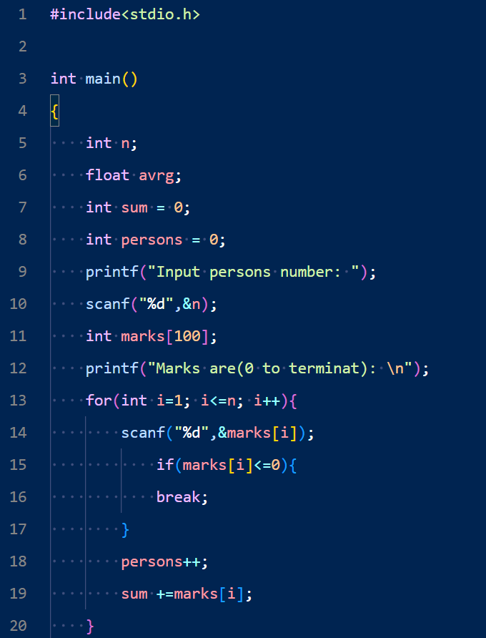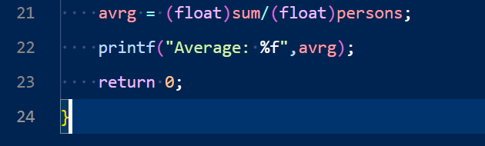Output:

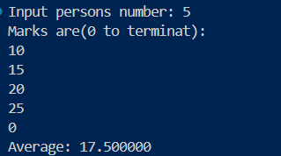

Problem No: 2302056_45

Problem Name: Write a C program to calculate the value of S where S = 1 + 1/2 + 1/3 + … + 1/50.

Input:

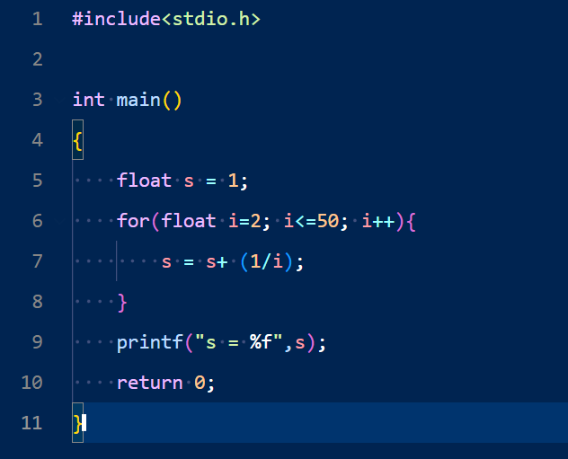

Output:



Problem No: 2302056_46

Problem Name: Write a C program to calculate the value of S where S = 1 + 3/2 + 5/4 + 7/8.

Input:

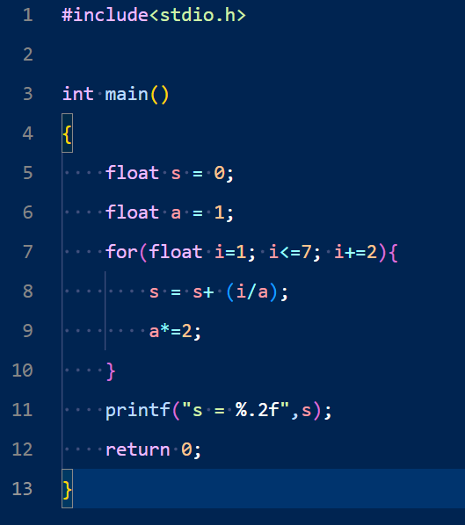

Output:



Problem No: 2302056_47

Problem Name: Write a C program that finds all the divisors of an integer.

Input:

Output:

Problem No: 2302056_48

Problem Name: Write a C program that reads and prints the elements of an array of length 7. Before printing, replace every negative number, zero, with 100.

Input:

Output:

Problem No: 2302056_49

Problem Name: Write a C program to read and print the elements of an array with length 7. Before printing, insert the triple of the previous position, starting from the second position.  
For example, if the first number is 2, the array numbers must be 2, 6, 18, 54 and 162

Input:

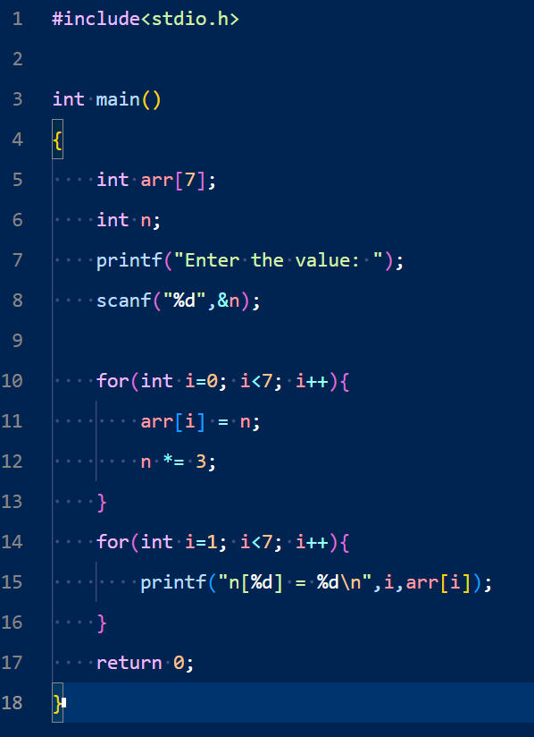Output:

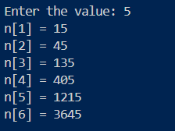

Problem No: 2302056_50

Problem Name: Write a C program to read an array of length 5 and print the position and value of the array elements of value less than 5.

Input:

Output:

